### Love Birds Pop-Up Card

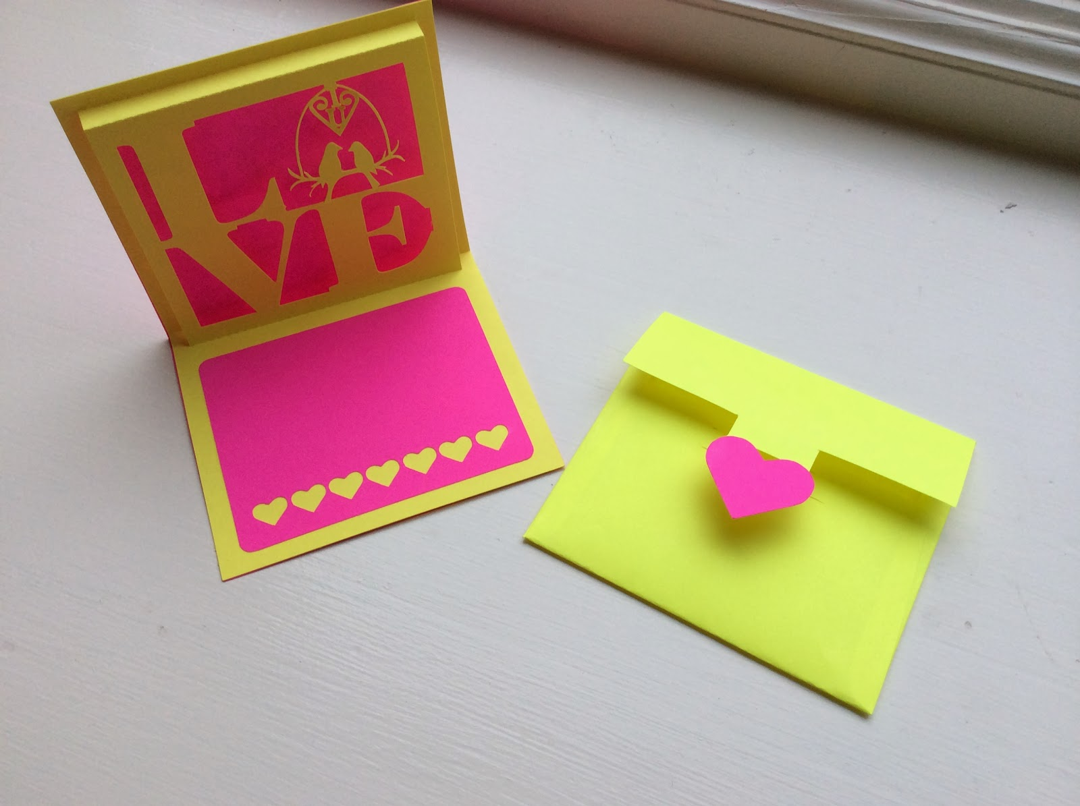

Love Birds Pop-Up Card

Here is a pop-up card for the one you love...two love birds sitting on a branch.   
  
We feed the birds in the winter and I love looking out the window to watch all of the birds coming to my bird feeder. We have bluebirds, cardinals, yellow finches, juncos, woodpeckers and an assortment of other birds. We feed the birds so that our kitties can watch from their perch in the house. We call it bird television. It keeps them occupied for hours looking at their friends.

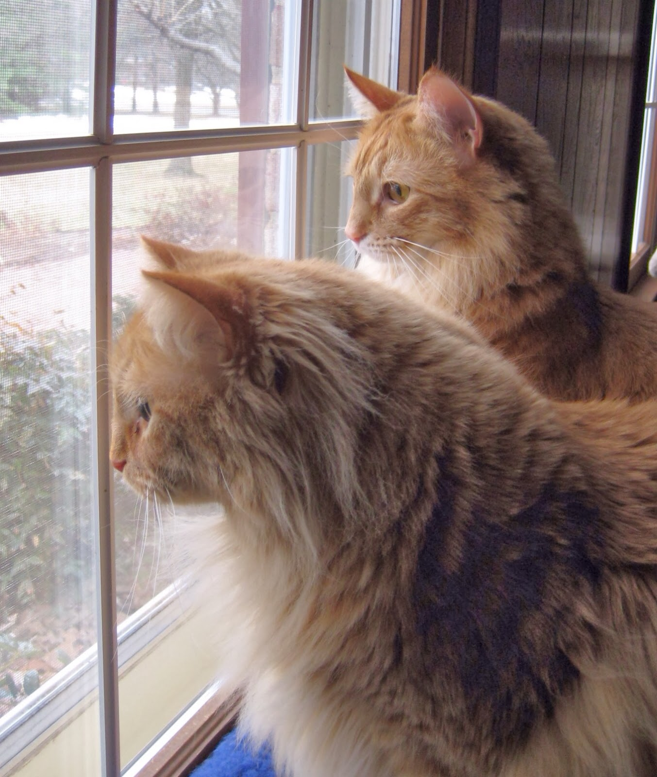

My kitties watching their bird friends eating sunflower seeds.